REPORT - ONE DAY WORK SHOP ON PERSONALITY DEVELOPMENT PROGRAM
Date:23-12-2022 Venue: Auditorium, SNVPMV
Sarojini Naidu Vanita Pharmacy Maha Vidhyalaya in Association with Disha Bharath TS branch has organized One Day work shop on Personality Development Program with a view to inculcate and improve over all personality development of the students. Total number of participants attended the program were 170 members including students, faculty & DB volunteers.
The event was anchored by B.Vyshnavi and Lisa Patel of B.Pharm 4th year and program started by inviting the guests on to dais for lightening the lamp with students and followed by a prayer song. The gathering was addressed by Principal of SNVPMV Dr. T. Saritha Jyotsna, explained the importance of Indian cultures and morals to lead a better professional and personal life. As a part of the event Chief Guest eminent Magician, Gunnies world record holder Sri Samala Venu started the work shop at 9.45 am with the introduction of the speakers Dr Pramodh Natarajan, Mrs. Sneha Damle, Dr. Pruthu and Mrs. Vennela Reddy and how Disha Bahrath team is contributing the nation by conducting the PDP in various colleges in India.
The work shop was divided into 5 sessions. The First session was started with Yoga asana and pranayama where Dr Pramodh Natarajan sir showed Kapalabathi, Bramari, Vajrasana, Surya namaskaras , breathing exercises and some asana on chairs in sitting posture and he explained how to get the benefit of yoga in 3 min by sitting at any place & anywhere for relieving head ache. Throughout the session all the participants were enthusiastic and followed the instructions of him without any deviation. The Second session was started with the Self Awareness Questionnaire, where the students were asked to write the answers to the questionnaire which includes 10 questions from that organizer concluded how to know about ourselves to see the better version of you in everyday. The Third session was started with Namaste Quiz by dividing the students into 5 groups where some eminent pictures of the Indian History and leaders were shown to the students and given the marks to declare the winners, with this session they want to shows Indian heritage and leaders who lead the world for the betterment of the nation after this lunch was announced.
The Fourth session was started by playing Audio visuals where total 3AV were played which was completely based on Humanity and responsibilities of every citizens, later the students were asked regarding the prospective of AV and session was conclude by Mrs. Sneha by giving the inspirational quotes of Swamy Vivekananda, with this session they enlighten the students about the seva and how to be a good human being. Fifth session they conducted Army games, where all the students have actively participated by coordinating each other with this they want to show the physical strength and team work. Finally the Seminar was closed with a magic show by Samala Venu sir.
The work shop was very Interactive, enthusiastic, Emotional, Interesting, and Engaging to the students. Felicitation was done to the speakers by Dr. N. Srinivas Director SNVPMV, Dr. T. Saritha Jyotsna, Principal SNVPMV and Dr. T. Mamatha Vice Principal SNVPMV. The vote of thanks was given by Dr.T.Mamatha, Vice Principal SNVPMV and thanked all coordinator and students for successful conduction of the event.
After the student work shop separate orientation session is conducted for DB –Volunteers of our college to explain the future plans of Disha Bharat to address the young students of various age groups.
Mrs. Sneha explained about life events of Swamy Vivekananda and enlightens us about the mission & vision of Swamy Vivekanada on education system. Future plans of Disha Bharat to celebrate the 161st Birth anniversary of Swamy Vivekanada how to take forward his speeches to educated the students and finally she concluded by inviting the faculties to take part in the Disha Bharat training program to train as a leader to take a part of “Swamy Vivekanada vision is my mission .
On 24/12/22 Mrs. Rajeswari, Ms. Varsha, Dr. Sujala, M. Swetha, Dr. Hadiya Irum, Dr. Shiva Rama Krishna & Mr. Srikanth from SNVPMV attended the training program at Keshava Nilayam, Bharkathpura where they taught different yoga techniques, how to address the gathering, how to do student counseling, future plans of Disha Bharath TS branch to reach maximum audience, how to handle the toughest situations and how to consider everything with a positive approach .
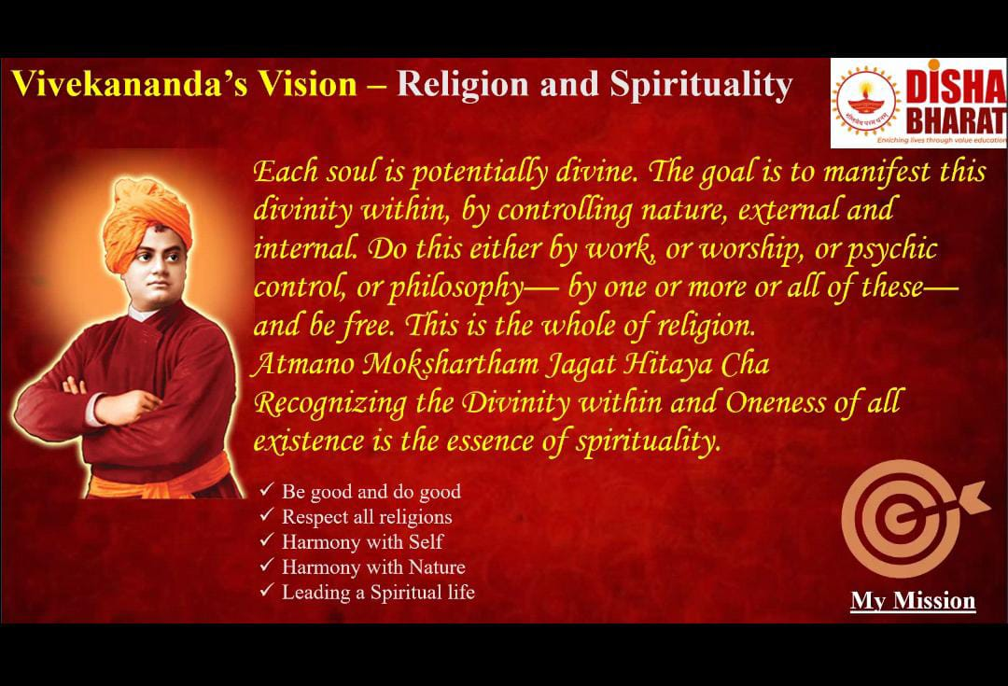
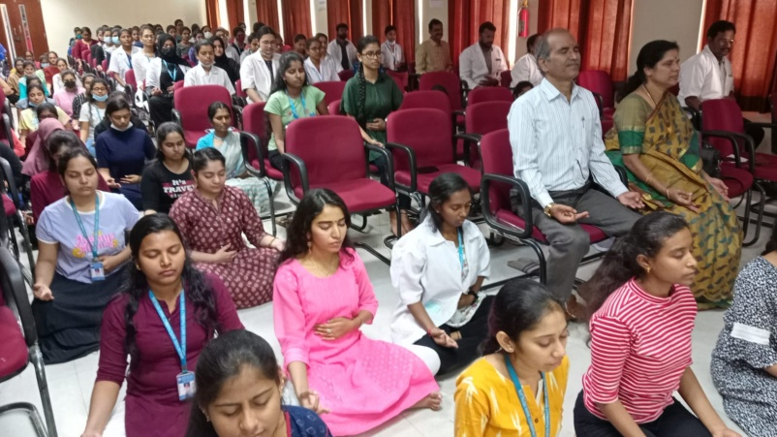 | 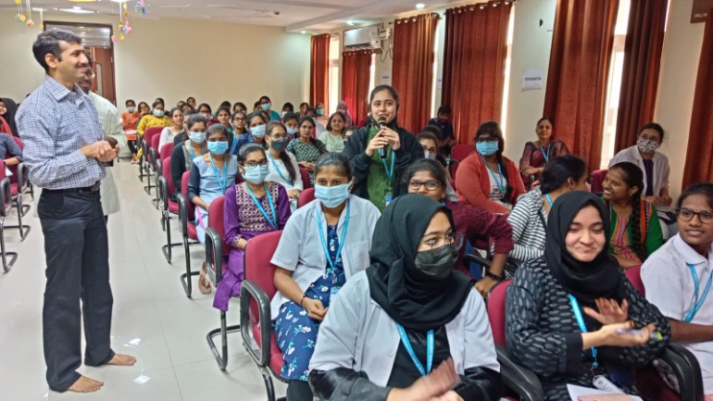
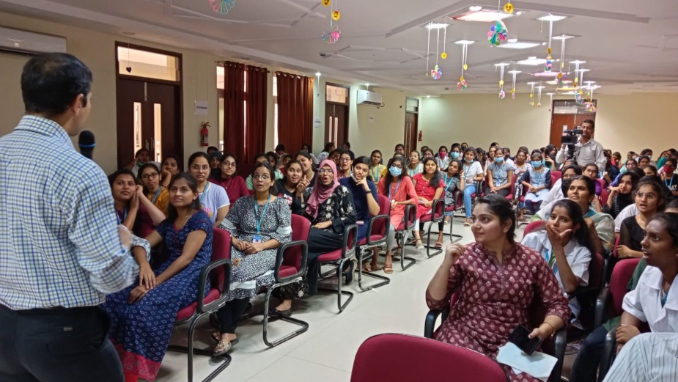 | 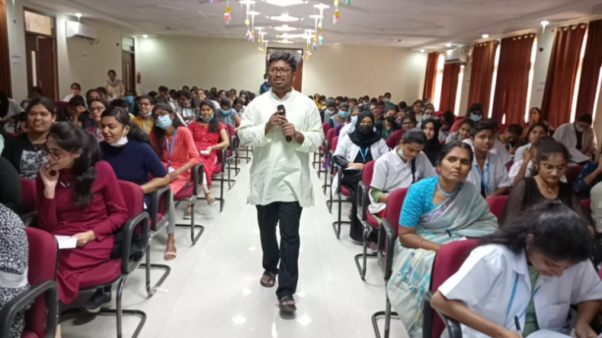
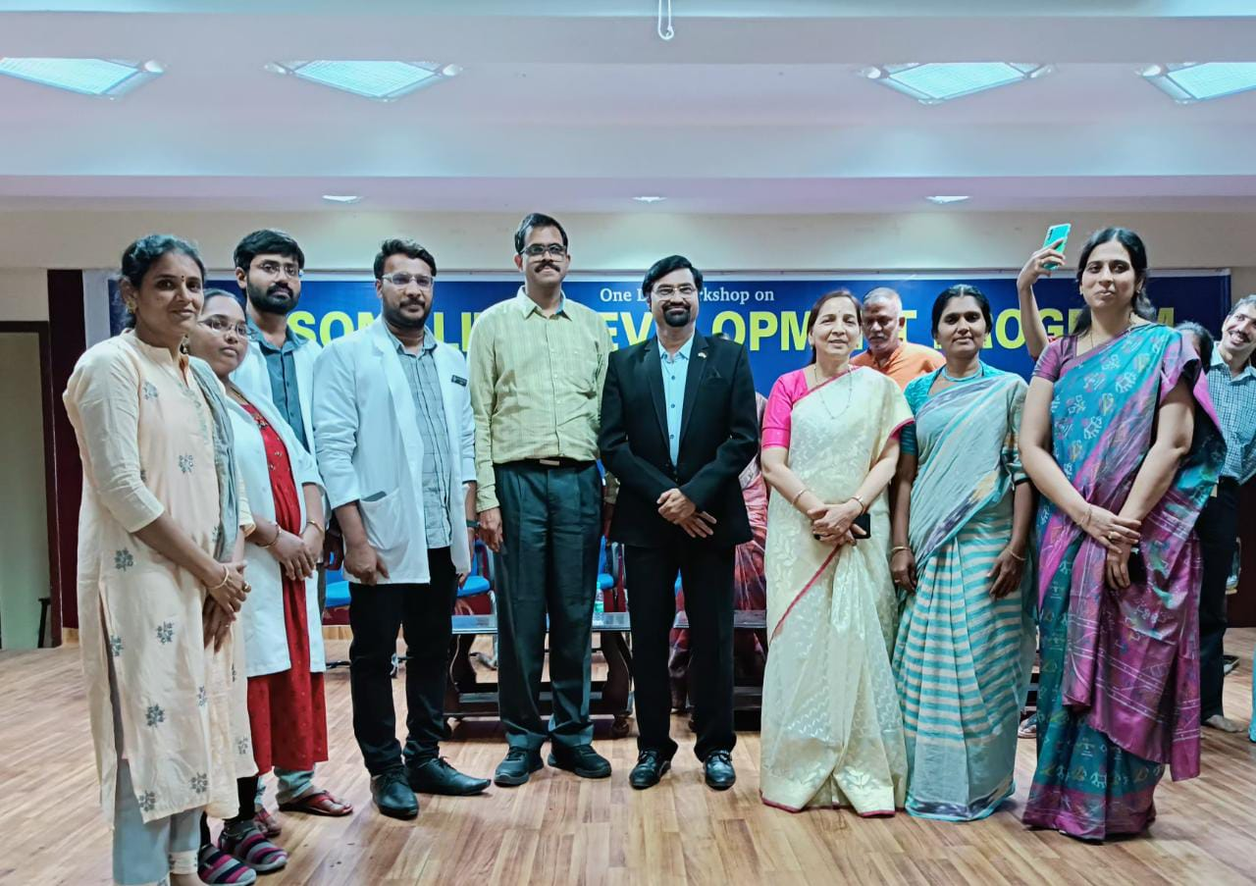 | 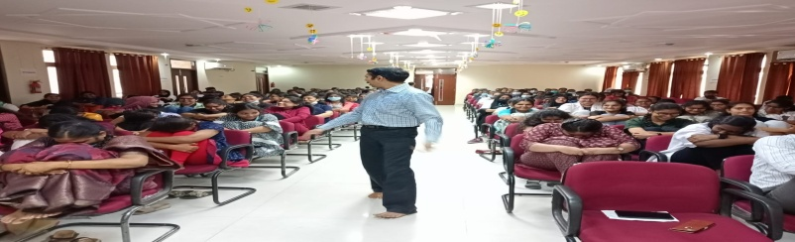
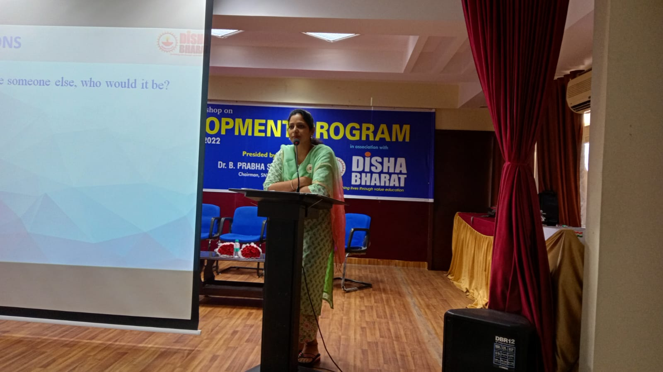 | 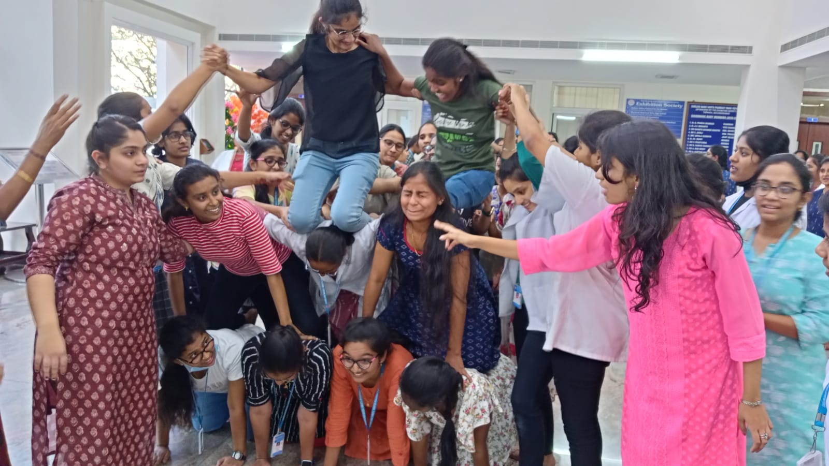
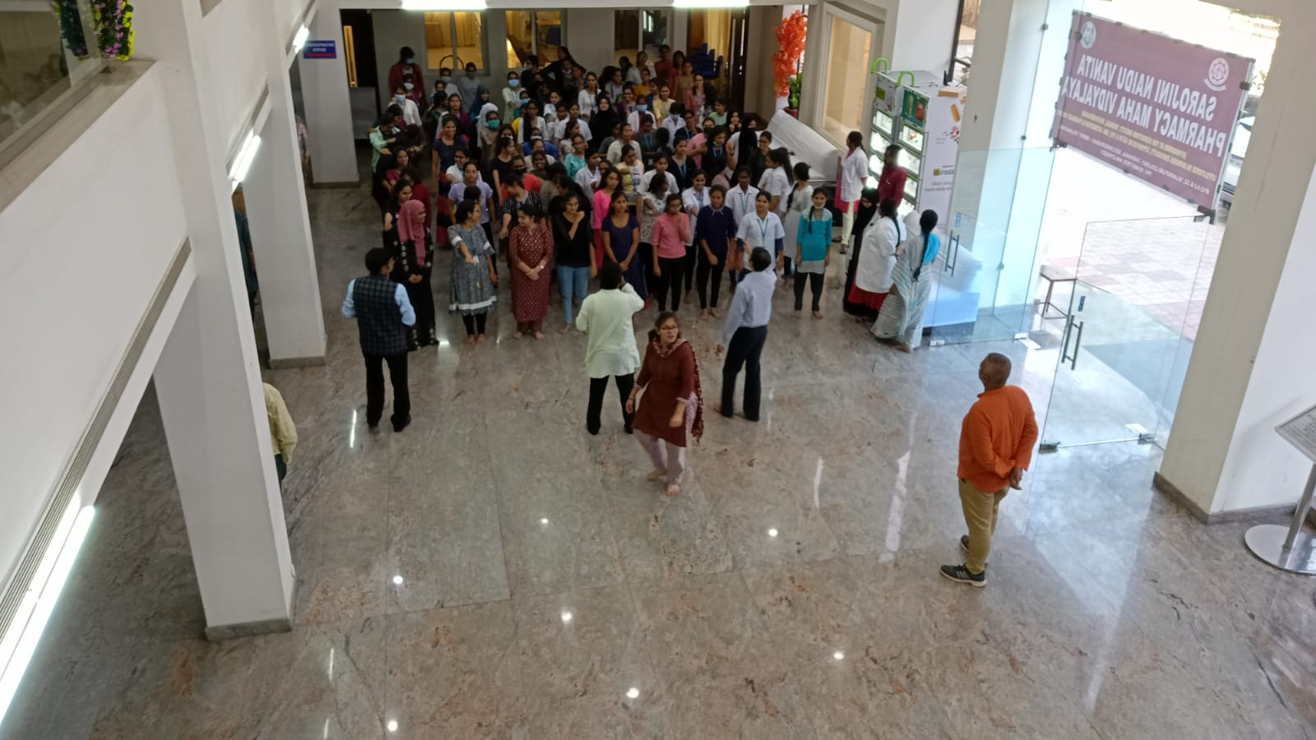 | 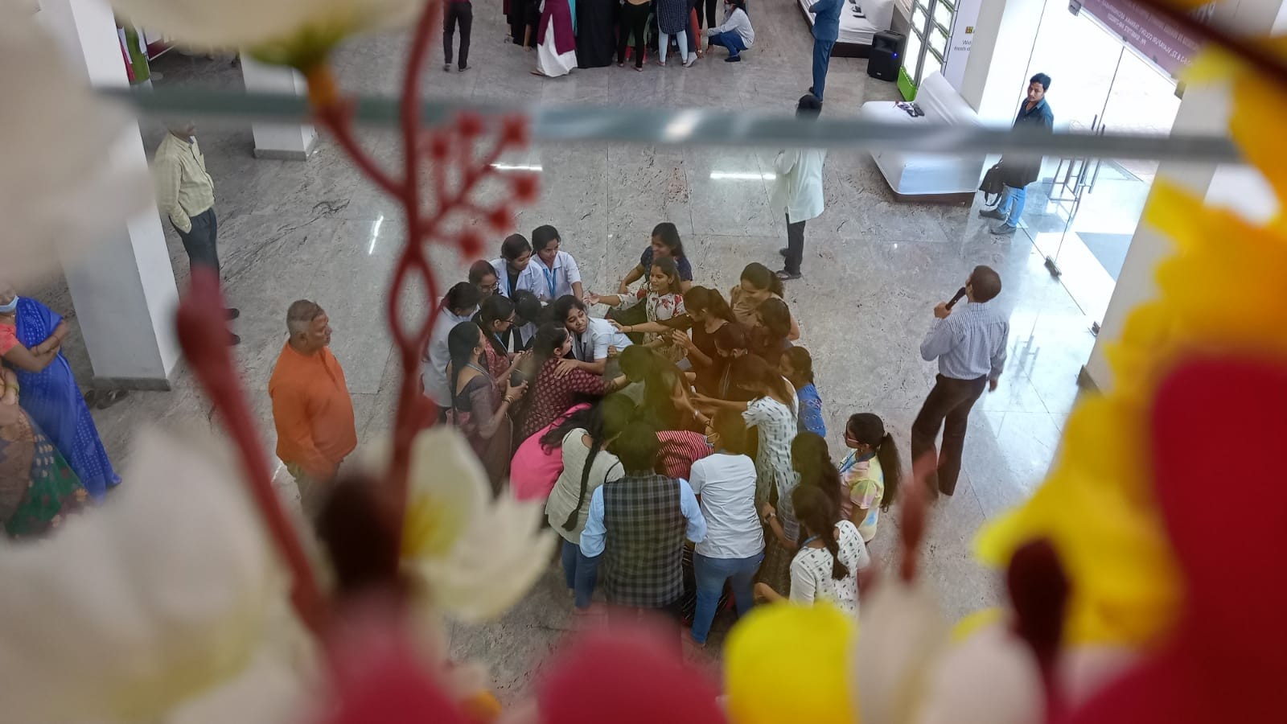
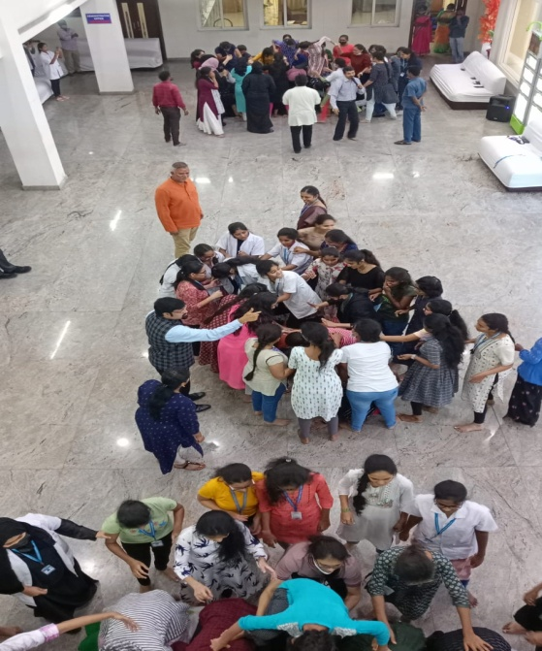 | 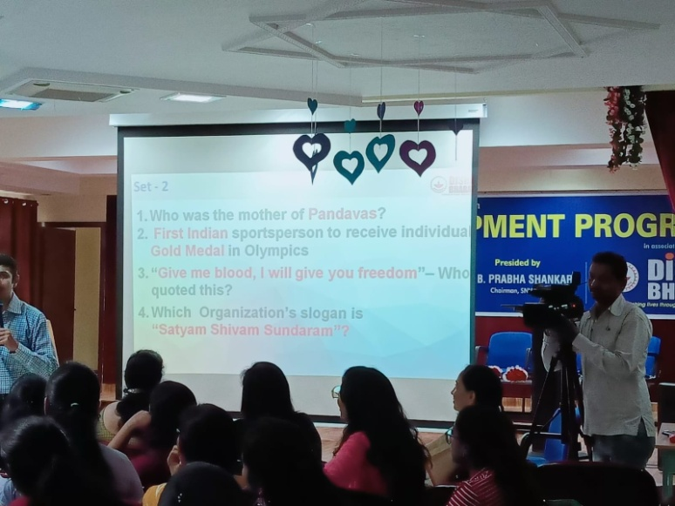
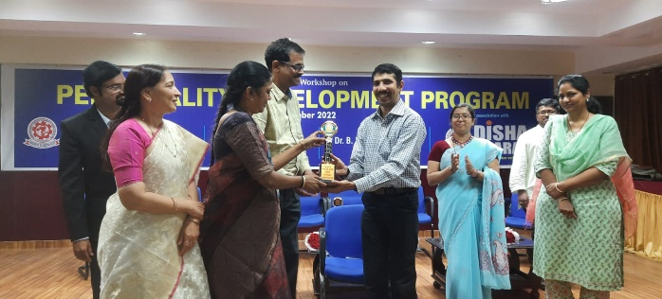 | 