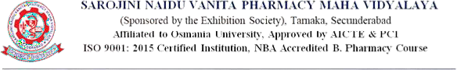

6.3.2. Audited statement of account highlighting the financial support to teachers to attend conferences / workshop s and towards membership fee for professional bodies

S. No | File Description | Link
1 | Audited statement of account highlighting the financial support to teachers to attend conferences / workshop s and towards membership fee for professional bodies

