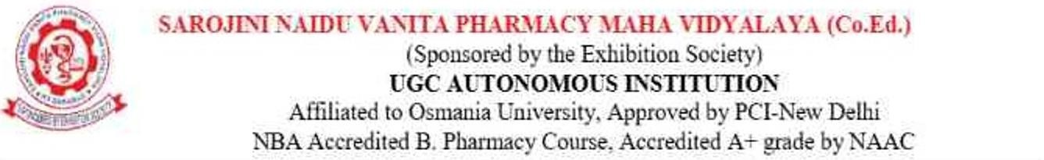

REPORT ON TRADITIONAL DAY CELEBRATIONS
Sarojini Naidu Vanita Pharmacy Maha Vidyalaya (SNVPMV)
Date: 2nd April 2026

Sarojini Naidu Vanita Pharmacy Maha Vidyalaya (SNVPMV) successfully organized a vibrant and culturally rich Traditional Day on 2nd April 2026. The event aimed to celebrate the diverse cultural heritage of India by showcasing major festivals and traditions from different regions of the country. The program witnessed enthusiastic participation from students, faculty, and staff.
The celebration highlighted various Indian festivals including Bathukamma, Dussehra, Christmas, Ugadi, Vinayaka Chavithi, Krishnashtami, Sankranthi, and Onam, reflecting unity in diversity and promoting cultural awareness among students.

Event Schedule and Highlights
09:00 AM – 11:30 AM: Festival Showcase Competition & Stalls
The day began with a colourful festival showcase competition where students creatively represented different Indian festivals through decorations, traditional attire, and thematic presentations. Multiple stalls were also arranged, offering traditional foods, cultural displays, games, and festive items, which attracted great interest and participation from attendees.
11:30 AM – 12:30 PM: Flash Mob & Fashion Show
A lively flash mob energized the audience, followed by a traditional fashion show where students elegantly displayed attire representing different states and festivals of India. The event highlighted the richness of Indian textiles and traditions.
12:30 PM – 01:30 PM: Lunch Break
Participants and attendees enjoyed a break with refreshments, sharing moments of joy and interaction.
01:30 PM – 04:00 PM: Cultural Performances
The afternoon session featured a variety of cultural performances including dance, singing, and other artistic programs. Students performed classical, folk, and contemporary pieces inspired by Indian traditions and festivals.

04:00 PM – 05:00 PM: DJ Session
The event concluded with an energetic DJ session where students celebrated with music and dance, bringing the day to a joyful end.
Conclusion
The Traditional Day celebration at SNVPMV was a grand success, fostering cultural appreciation, teamwork, and creativity among students. The event not only provided entertainment but also served as an educational experience, reinforcing the importance of preserving and celebrating India’s rich cultural heritage.
The management, faculty, and organizing cultural committee extended their full support, ensuring the smooth conduct of the program. The active participation of students made the event memorable and impactful.

Outcomes of Traditional Day:
- Enhanced awareness and appreciation of India’s diverse cultural traditions and festivals among students.
- Encouraged teamwork, creativity, and active student participation through competitions and performances.
- Provided a platform to showcase talents in dance, music, fashion, and event management.
- Strengthened coordination and organizational skills through stall management and event execution.
- Promoted unity, inclusiveness, and cultural bonding within the institution.

