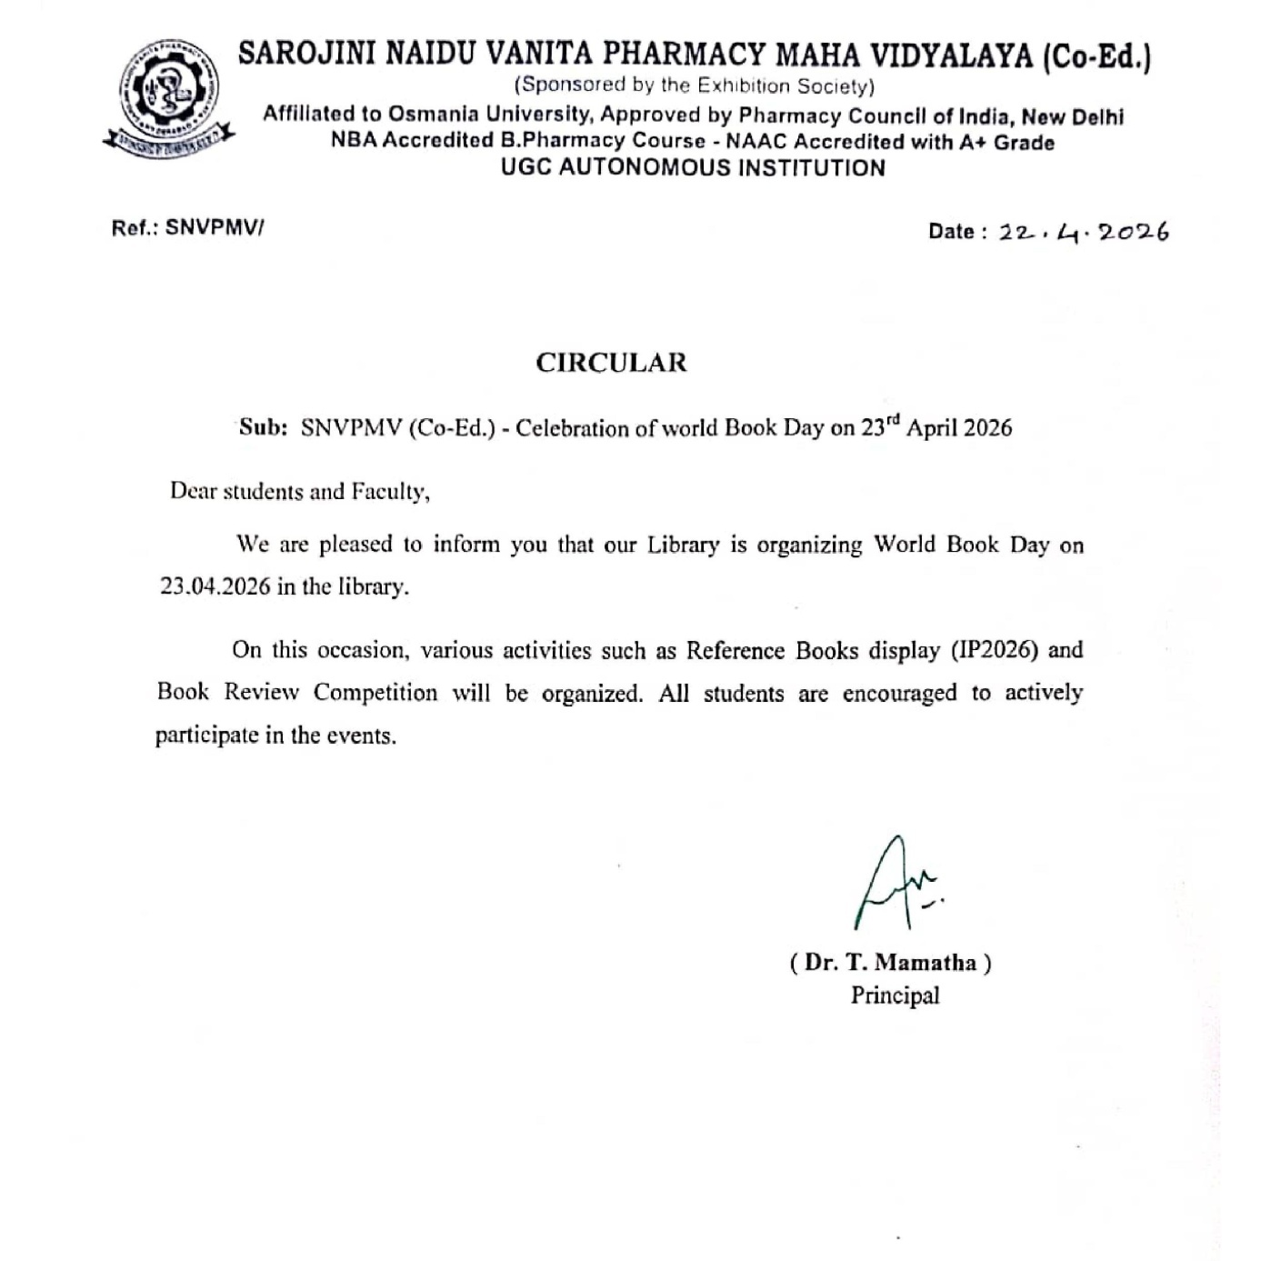

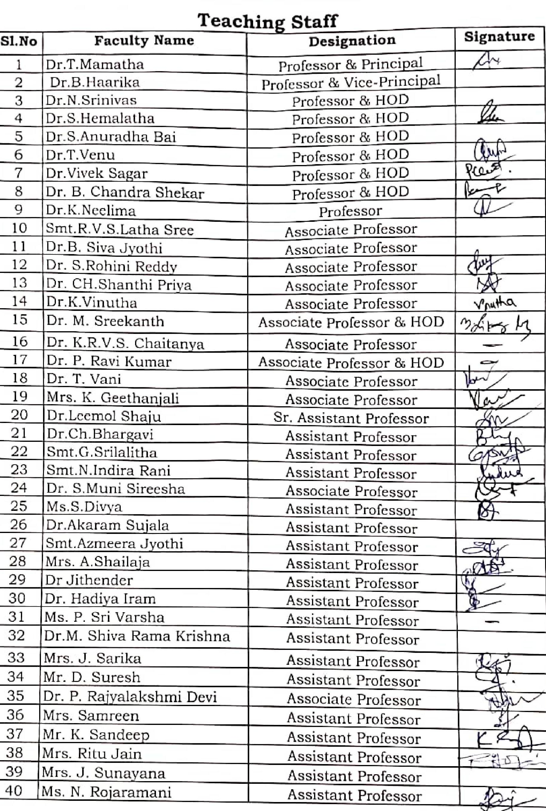

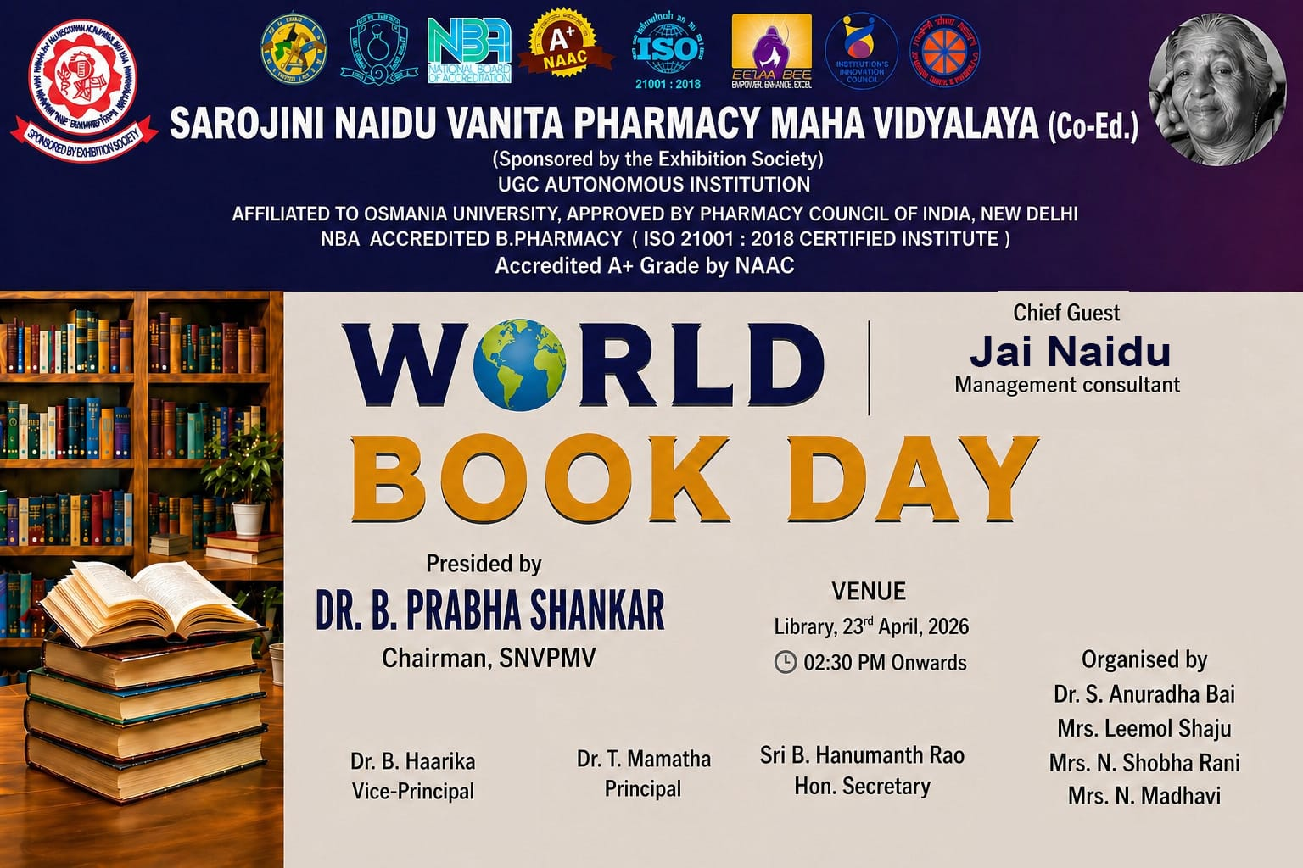

REPORT ON WORLD BOOK DAY & COPYRIGHT DAY CELEBRATIONS – 2026

Date: 23rd April 2026
Venue: SNVPMV (Co-Ed.) Library

World Book Day and Copyright Day were celebrated with immense enthusiasm at the Sarojini Naidu Vanita Pharmacy Maha Vidyalaya (SNVPMV) Library on April 23, 2026. The program served as a global tribute to literature, encouraging the academic community to rediscover the profound impact of physical books in an increasingly digital age.
The event was graced by a distinguished panel of guests and institutional leaders:
- Chief Guest: Mr. Jai Naidu, Management Consultant and Career Guidance Coach, Pune. Smt. Anupama
- Special Guest: Mrs. Sirisha.Baile, Deputy Manager and Research Scientist at BHEL corporate R& D
- Library Committee: Dr. T. Mamatha (Principal), Dr. B. Haarika (Vice-Principal), and Mrs. B. Sirisha (Governing Body Member).
- Dr. S. Anuradha (Professor & HOD, PQA), Dr. Leemol Shaju (Sr. Asst. Professor), and the Library team, Mrs.N. Shobha Rani.and Mrs.N.Madhavi
Objectives
- To promote a sustainable reading culture and emphasize the value of physical books over digital media.
- To provide technical insights into essential pharmaceutical literature.
- To bridge the gap between academic learning and personal growth through diverse literature.
The program commenced with a warm welcome to the guests, followed by a series of inspiring addresses:
- Dr. T. Mamatha emphasized that "books have the power to transport us to different worlds." She provided a detailed overview of the Indian Pharmacopoeia-2026 and urged students to rely on authoritative printed texts rather than unverified online sources. She also announced future plans to implement an "Open Book System" for certain tests and book-referenced assignments to ensure proper library utilization.
- Dr. B. Haarika described reading as "an investment with high returns." She guided students through the technical nuances of IP-2026, various professional journals, and critical reference books essential for the pharmacy profession.
- B.Sirisha described reading of books not only increases our Knowledge but also gives us happiness and peace. Books can take us different worlds and teach us valuable lessons .let us develop the habit of reading every day and make books a part of our life. Our library Possesses a vast collection, and students are encouraged to make full use of its services.
- Dr. S.Anuradha discussed how book reading improves imagination, fosters a focused mindset, and builds deep knowledge.
- Dr. B. Chandra Shekhar Reddy and Dr. Leemol Shaju further spoke on the holistic benefits of reading for both daily life and academic excellence.
- Chief Guest’s: Mr. Jai Naidu traced the history of World Book Day, In 1995, the organization UNESCO officially declared April 23 as World Book Day . This date is significant because it marks the death anniversaries of famous writers:
    - William Shakespeare
    - Miguel de Cervantes
    - Inca Garcilaso de la Vega
- Advocated for the sensory pleasure and happiness found in printed books. He encouraged the students to develop a habit of reading one page loudly every day to improve clarity and retention. In a generous gesture, he presented copies of the book E=mc² to several high-achieving students.
The event saw vibrant engagement from M.Pharm, B.Pharm, and Pharm.D students:
- The event was gracefully anchored by Ms. Javali.B.Pharm final year student
- Several students delivered speeches reflecting on the theme of World Book Day 2026.
- The Chief GuestMr. Jai Naidu presented the book E=mc² to students including B. Ram, D. Saravanthi, Ravi Varma, B. Rahul, D. Ashok (M. Pharm); Javali, Hamsika, Aarzoo (B. Pharm Final Year); Rishika, Manogna (Pharm.D III Year); R. Prasanna, D. Sneha, Sumalatha (B. Pharm 2nd Year); and others from Pharm.D IV Year and B. Pharm 3rd Year (Honeysha, Sana, Hiba, Keerthana, etc.).
The program concluded with a formal Vote of Thanks proposed by Dr. S. Anuradha, Professor & HOD, PQA.
- She expressed profound gratitude to the Management for their unwavering support in organizing such academic initiatives.
- A special note of thanks was extended to the Chief Guest, Sri Jai Naidu garu, for his inspiring presence and for gifting the students with the treasure of books.
- She acknowledged Smt. Anupama and Smt. B. Sirisha (GB Member) for their valuable time and for encouraging the students to look beyond their curriculum.
- Finally, she thanked the principal, faculty, librarians, and the enthusiastic student body whose active participation made the event a grand success.
Outcome of the program
The event encouraged the development of regular reading habits and created awareness about the importance of books in personal life and academic growth and encouraged better use of the of the library.
Impact of the Program
The celebration of World Book Day and Copyright Day 2026 at SNVPMV successfully reinforced the library's role as the "heart of the institution." By introducing the concept of the Open Book System &By bridging the gap between traditional reading and modern pharmaceutical standards like the IP-2026, the event left a lasting impact on the students, motivating them to become well-read, ethical, and knowledgeable pharmacy professionals.

